COMP3948 ASSIGMENT 2

Owen Arando

# Table of Contents

Introduction 2

Exploratory Data Analysis 2

Numeric Data 2

Numeric Data Dictionary 2

Distribution of Significant Numerical Features 3

Categorical Data 4

Categorical Data Dictionary 4

Distribution of Significant Categorical Features 5

Distributions of All Features 6

Correlations and Heatmaps 7

Heatmap of All Correlations 7

Heatmap of Significant Features 8

The Target 9

Distribution of Target Variable 9

Significant Features VS Target 9

Model Evaluation 11

Model Preparation 11

Models 11

Conclusion 13

# Introduction

In this report we will attempt to predict whether a customer will commit fraud based on a given dataset. To do this we will perform an Exploratory Data Analysis on the dataset. Then we will create Models using Logistic Regression and SMOTE. Afterwards, we will evaluate our models using cross fold validation and examine their accuracy, precision, recall and f1 scores. Finally, we will choose our preferred model and state our conclusions.

# Exploratory Data Analysis

We will start our EDA by going over the numeric and categorical data in our dataset. For both types of data, we will display a data dictionary, describing key properties of each feature and then displaying the distributions of their significant features.

To select these significant features, we found all features with a chi-squared score >= 3.8. Feature selection was also tested with RFE and Forward Feature Selection, but Chi Square produced the best results.

After examining both numeric and categorical features, you will see a visualization of the distribution of all features. Afterwards, we will go over heatmaps and the correlations of all features as well as the correlations of significant features. And finally, we will analyze our target variable and its relationship with significant factors.

## Numeric Data

### Numeric Data Dictionary

The data dictionary for numeric data can be seen below. In it we can see that AMT_INCOLME_TOTAL, AMT_CREDIT, AMT_ANNUITY and DAYS_BIRTH have missing values, these will need to be imputed. Additionally, the features with the AMT prefix are also a much higher order of magnitude than the other features. For these features, scaling would help, but as we find out later, these features are insignificant and dropped.

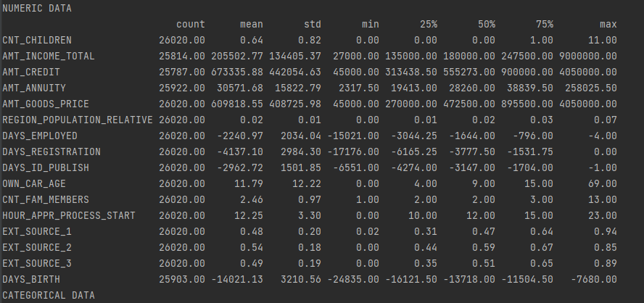

### Distribution of Significant Numerical Features

Below you can see the distributions of the most significant Numerical Features. The features with the EXT prefix are by far the most significant numeric features. DAYS_BIRTH is part of a series of features with all negative values and was the only one to have a chi square score >= 3.8 in our feature selection process.

It should be noted that these values may already be scaled, possibly by a MinMaxScaler as they are all between 0 and 1. Additionally out of these four features only two have outliers and the number of outliers is quite mild compared to other datasets.

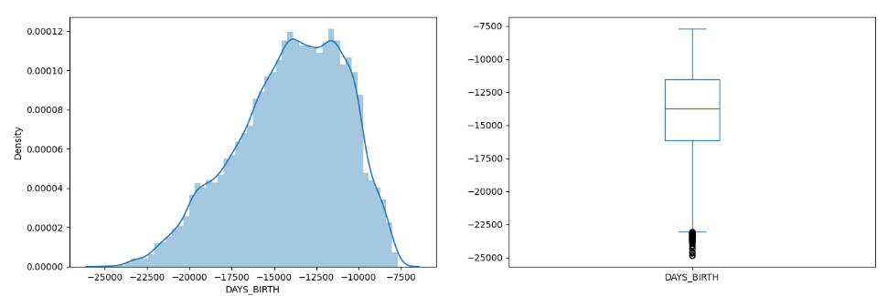

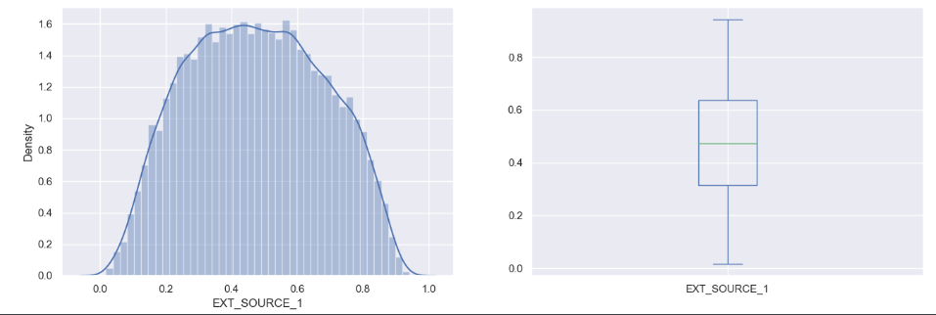

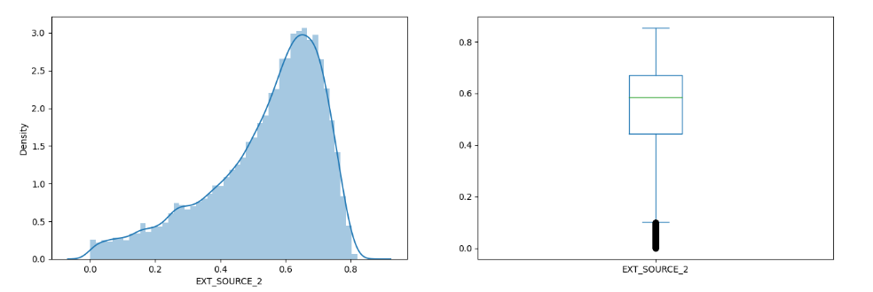

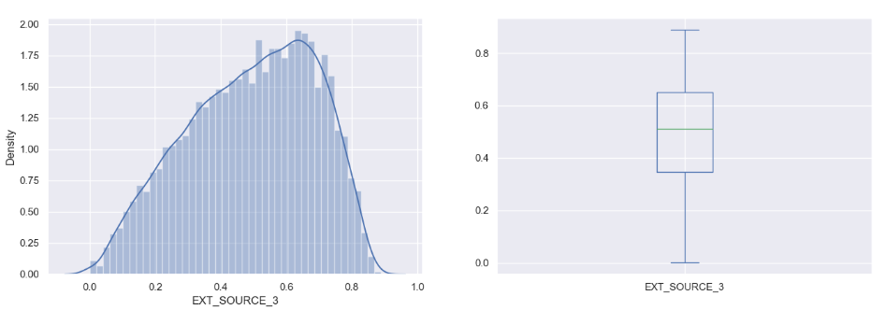

## Categorical Data

### Categorical Data Dictionary

The data dictionary for categorical data can be seen below. In it we can see that several of our categorical values have only one value or are extremely close to only having one value. These categories: FLAG_OWN_CAR, FLAG_MOBIL, FLAG_EMP_PHONE, and FLAG_CONT_MOBILE can be removed.

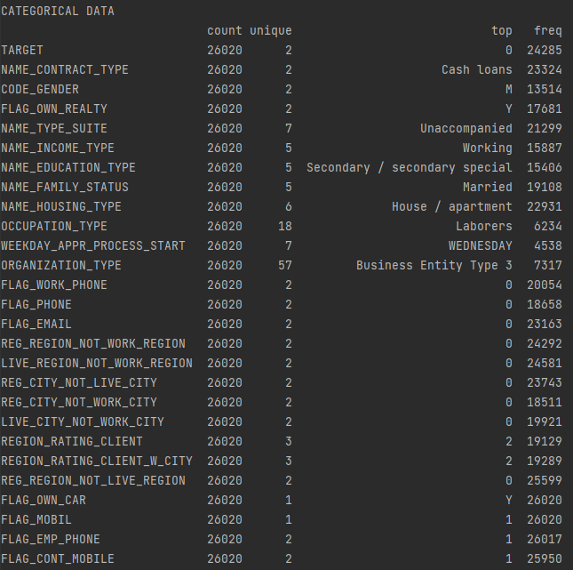

### Distribution of Significant Categorical Features

The distribution of significant categorical features can be seen below. Most of these features have only   
a few categories and are concentrated on an even smaller subset of categories. This makes these categories prime candidates for dummy variables. All these categories were identified as significant by Chi Squared.

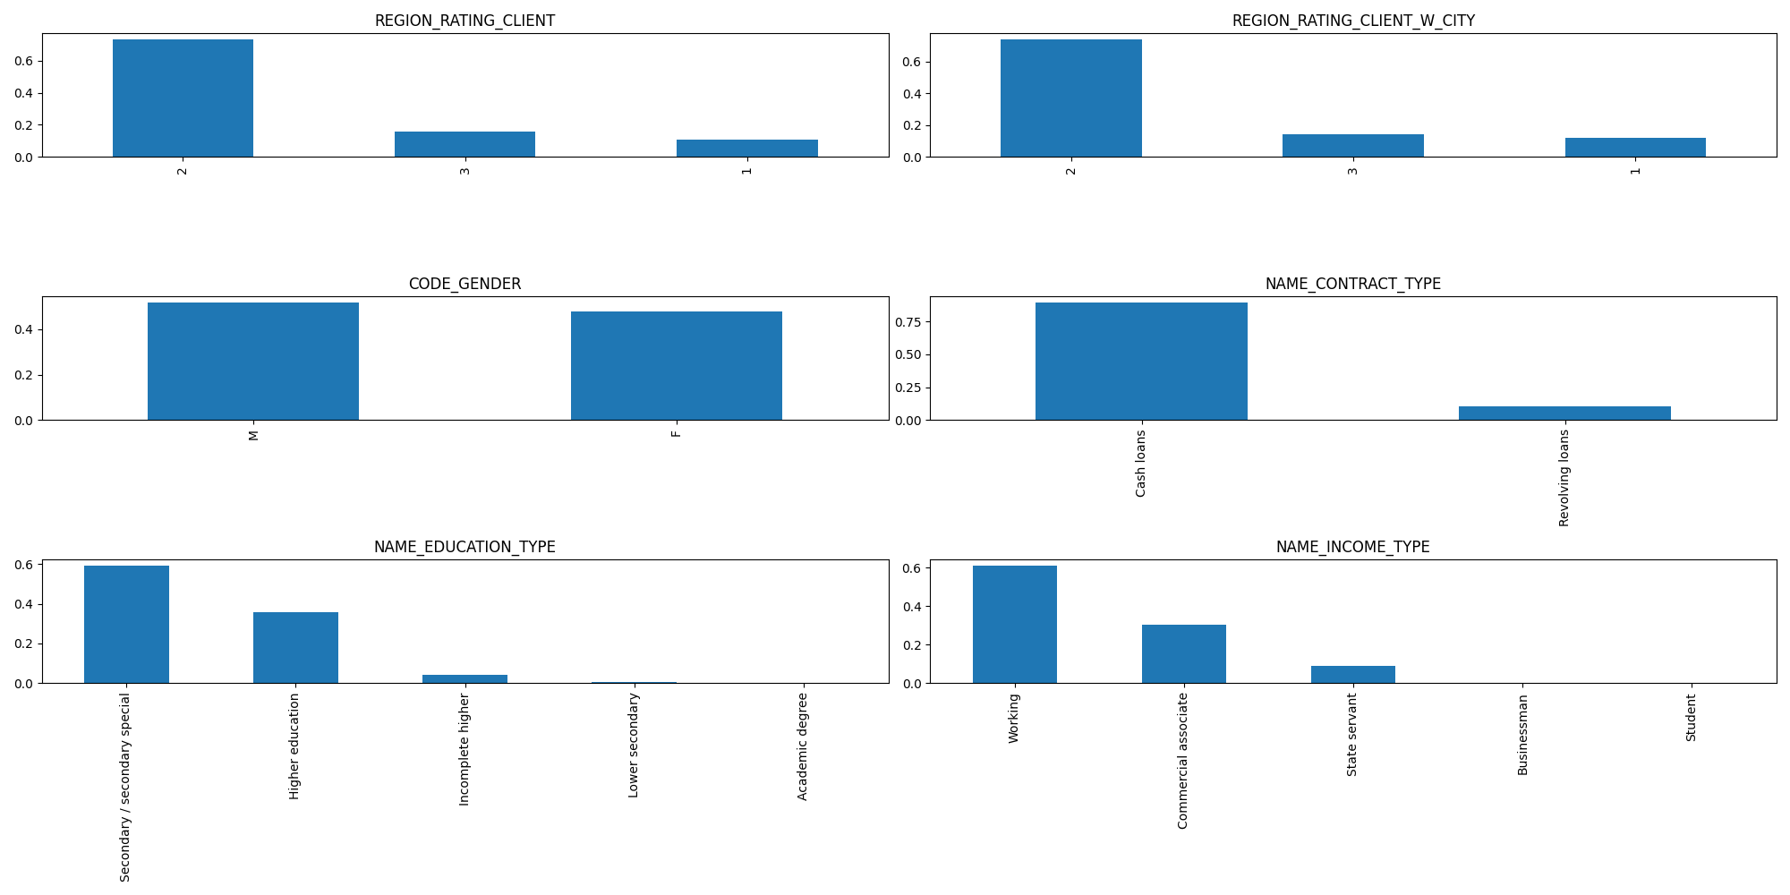

## Distributions of All Features

Below we can see histograms of all numeric data and ordinal categorical data—any data that is represented by a number without the need to be dummied.

## Correlations and Heatmaps

### Heatmap of All Correlations

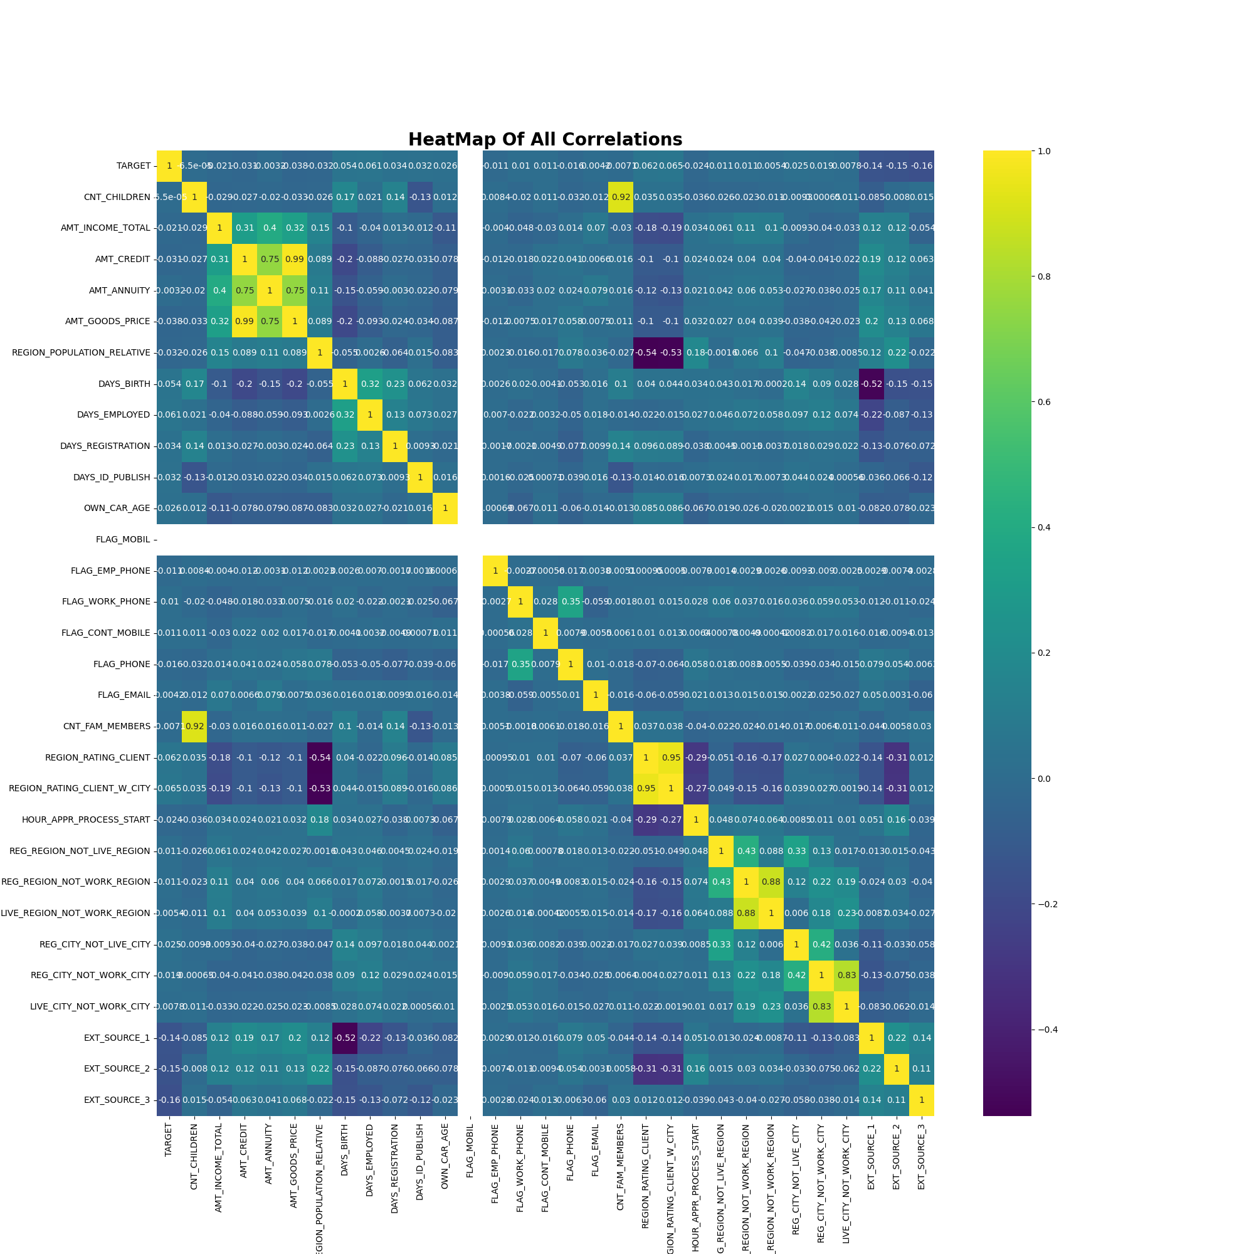

### Heatmap of Significant Features

Below you can see a heatmap of the significant numerical model features identified by Chi Square. Most features are independent which is good. However, there is a notable negative correlation between EXT_SOURCE_1 and DAYS_BIRTH.

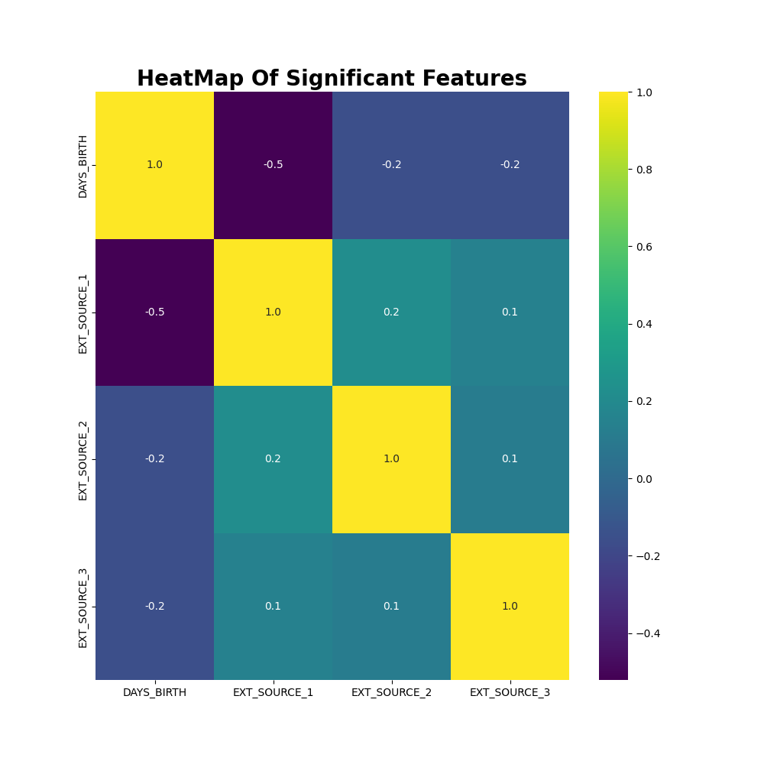

## The Target

### Distribution of Target Variable

Below you can see the distribution of the target variable. In this case, our data is heavily unbalanced. Most of our data is for samples in which no fraud has occurred. This resembles reality but will make for poor predictions. We will need to use SMOTE to resample our dataset.

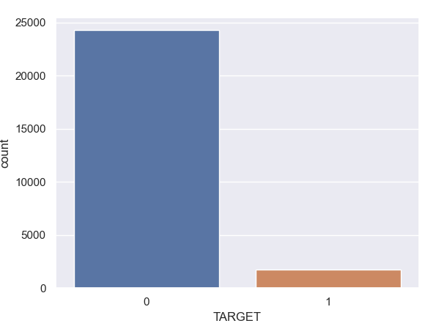

### Significant Features VS Target

Shown below are significant categorical features and their relationships to target variables. When looking for significance, one should look at the ratio of the target value for each category, not the overall amount of data in a category. For example, in CODE_GENDDER even though the amount of data is almost equivalent for men and women it is clear that proportionally, men are more likely to commit fraud than women.

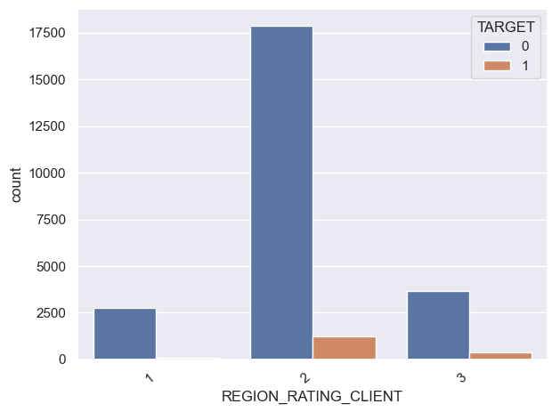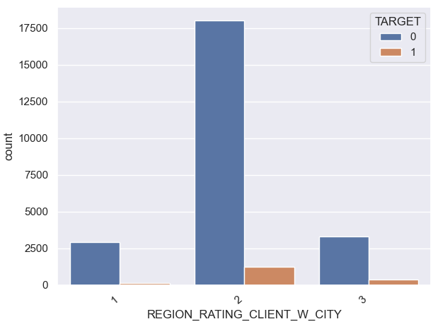

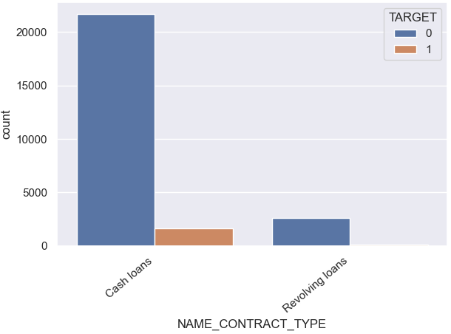 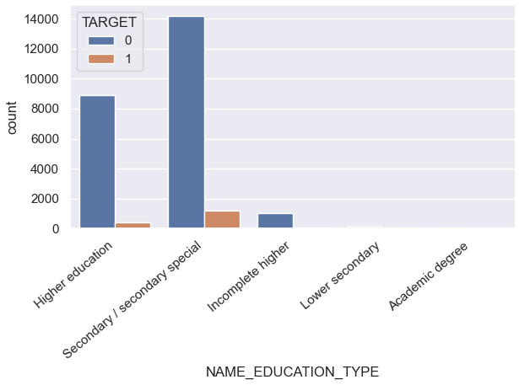

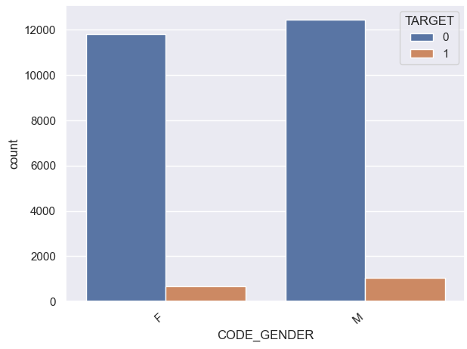 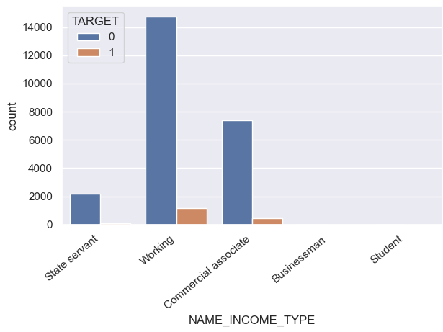

# Model Evaluation

In this section we will explain our modelling process. We will first outline the data preparation behind the models, then have a look at the models themselves and finally, we will select a model.

## Model Preparation

All models below share the following preparations. First categorical features with only one value were removed. Then categorical features were dummied. For these, we had K-1 dummies made for K values in a category to be efficient with the number of features produced. After creating dummies, we had 155 features. After all our features could be processed as a numerical value, we used KNN imputation to fill in the missing values we had for some numerical features. Then, we reduced these 155 features down to 41 using Chi Square as explained previously in the EDA. From this point we made several models based on binning and further reducing our selected features to keep our models as simple as possible. All models were evaluated using Cross Fold Validation.

## Models

The models can be seen and are described below.

|  |  |  |  |
| --- | --- | --- | --- |
| Model | A | B | C |
| Features | ORGANIZATION_TYPE$Trade: type 3  ORGANIZATION_TYPE$Legal Services  DAYS_BIRTH  NAME_FAMILY_STATUS$Married  ORGANIZATION_TYPE$Construction  ORGANIZATION_TYPE$School  FLAG_PHONE$1  ORGANIZATION_TYPE$Self-employed  OCCUPATION_TYPE$Low-skill Laborers  NAME_HOUSING_TYPE$Rented apartment  NAME_FAMILY_STATUS$Civil marriage  NAME_INCOME_TYPE$Commercial associate  REG_CITY_NOT_WORK_CITY$1  NAME_FAMILY_STATUS$Single / not married  ORGANIZATION_TYPE$Bank  ORGANIZATION_TYPE$Government  OCCUPATION_TYPE$Managers  ORGANIZATION_TYPE$Business Entity Type 3  OCCUPATION_TYPE$Sales staff  OCCUPATION_TYPE$Security staff  NAME_INCOME_TYPE$Working  ORGANIZATION_TYPE$Transport: type 3  OCCUPATION_TYPE$High skill tech staff  OCCUPATION_TYPE$Core staff  OCCUPATION_TYPE$Laborers  REG_CITY_NOT_LIVE_CITY$1  NAME_INCOME_TYPE$State servant  OCCUPATION_TYPE$Accountants  OCCUPATION_TYPE$Drivers  NAME_HOUSING_TYPE$With parents  CODE_GENDER$M  NAME_CONTRACT_TYPE$Revolving loans  NAME_EDUCATION_TYPE$Secondary / secondary special  EXT_SOURCE_2  REGION_RATING_CLIENT$1  REGION_RATING_CLIENT_W_CITY$1  EXT_SOURCE_1  REGION_RATING_CLIENT$3  EXT_SOURCE_3  NAME_EDUCATION_TYPE$Higher education  REGION_RATING_CLIENT_W_CITY$3 | ORGANIZATION_TYPE$Trade: type 3  ORGANIZATION_TYPE$Legal Services  NAME_FAMILY_STATUS$Married  ORGANIZATION_TYPE$Construction  ORGANIZATION_TYPE$School  FLAG_PHONE$1  ORGANIZATION_TYPE$Self-employed  OCCUPATION_TYPE$Low-skill Laborers  NAME_HOUSING_TYPE$Rented apartment  NAME_FAMILY_STATUS$Civil marriage  NAME_INCOME_TYPE$Commercial associate  REG_CITY_NOT_WORK_CITY$1  NAME_FAMILY_STATUS$Single / not married  ORGANIZATION_TYPE$Bank  ORGANIZATION_TYPE$Government  OCCUPATION_TYPE$Managers  ORGANIZATION_TYPE$Business Entity Type 3  OCCUPATION_TYPE$Sales staff  OCCUPATION_TYPE$Security staff  NAME_INCOME_TYPE$Working  ORGANIZATION_TYPE$Transport: type 3  OCCUPATION_TYPE$High skill tech staff  OCCUPATION_TYPE$Core staff  OCCUPATION_TYPE$Laborers  REG_CITY_NOT_LIVE_CITY$1  NAME_INCOME_TYPE$State servant  OCCUPATION_TYPE$Accountants  OCCUPATION_TYPE$Drivers  NAME_HOUSING_TYPE$With parents  CODE_GENDER$M  NAME_CONTRACT_TYPE$Revolving loans  NAME_EDUCATION_TYPE$Secondary / secondary special  EXT_SOURCE_2  REGION_RATING_CLIENT$1  REGION_RATING_CLIENT_W_CITY$1  EXT_SOURCE_1  REGION_RATING_CLIENT$3  EXT_SOURCE_3  NAME_EDUCATION_TYPE$Higher educationa  REGION_RATING_CLIENT_W_CITY$3  DAYS_BIRTH$(-24835.0, -23691.333]  DAYS_BIRTH$(-23691.333, -22547.667]  DAYS_BIRTH$(-22547.667, -21404.0]  DAYS_BIRTH$(-21404.0, -20260.333]  DAYS_BIRTH$(-20260.333, -19116.667]  DAYS_BIRTH$(-19116.667, -17973.0]  DAYS_BIRTH$(-17973.0, -16829.333]  DAYS_BIRTH$(-16829.333, -15685.667]  DAYS_BIRTH$(-15685.667, -14542.0]  DAYS_BIRTH$(-14542.0, -13398.333]  DAYS_BIRTH$(-13398.333, -12254.667]  DAYS_BIRTH$(-12254.667, -11111.0]  DAYS_BIRTH$(-11111.0, -9967.333]  DAYS_BIRTH$(-9967.333, -8823.667] | REGION_RATING_CLIENT_W_CITY_3  NAME_EDUCATION_TYPE_Higher education  EXT_SOURCE_3  REGION_RATING_CLIENT_3  EXT_SOURCE_1  REGION_RATING_CLIENT_W_CITY_1  REGION_RATING_CLIENT_1  EXT_SOURCE_2  NAME_EDUCATION_TYPE_Secondary / secondary special  NAME_CONTRACT_TYPE_Revolving loans  CODE_GENDER_M  NAME_HOUSING_TYPE_With parents  OCCUPATION_TYPE_Drivers  OCCUPATION_TYPE_Accountants  NAME_INCOME_TYPE_State servant  REG_CITY_NOT_LIVE_CITY_1  OCCUPATION_TYPE_Laborers  OCCUPATION_TYPE_Core staff  OCCUPATION_TYPE_High skill tech staff  ORGANIZATION_TYPE_Transport: type 3  NAME_INCOME_TYPE_Working  OCCUPATION_TYPE_Security staff  OCCUPATION_TYPE_Sales staff  ORGANIZATION_TYPE_Business Entity Type 3  OCCUPATION_TYPE_Managers  ORGANIZATION_TYPE_Government  DAYS_BIRTH_BINS_(-24835.0, -23119.5]  DAYS_BIRTH_BINS_(-23119.5, -21404.0]  DAYS_BIRTH_BINS_(-21404.0, -19688.5]  DAYS_BIRTH_BINS_(-19688.5, -17973.0]  DAYS_BIRTH_BINS_(-17973.0, -16257.5]  DAYS_BIRTH_BINS_(-16257.5, -14542.0]  DAYS_BIRTH_BINS_(-14542.0, -12826.5]  DAYS_BIRTH_BINS_(-12826.5, -11111.0]  DAYS_BIRTH_BINS_(-11111.0, -9395.5] |
| Number of Features | 41 | 54 | 35 |
| Dummied | Yes | Yes | Yes |
| Binned | No | Yes | Yes |
| Avg. Accuracy | 0.6957340507302076 | 0.769292851652575 | 0.7121445042275173 |
| Std. Accuracy | 0.010376704529035385 | 0.006962554574831821 | 0.010654741016585319 |
| Avg. Precision | 0.13718994156085168 | 0.15205089780562867 | 0.13948581405893565 |
| Std. Precision | 0.00764451505849101 | 0.012531239479750078 | 0.012723189267146464 |
| Avg. Recall | 0.6741565753184371 | 0.5378085903115423 | 0.6400277198754254 |
| Std. Recall | 0.025129241055697065 | 0.043053653137572104 | 0.03773513038186724 |
| Avg .F1 | 0.22787514734390038 | 0.23686853939917568 | 0.22895521485730588 |
| Std. F1 | 0.011030689696610245 | 0.018103733409393963 | 0.01927567686203369 |
| Confusion Matrix |  |  |  |

Model A is our most basic model and is a good control for our other two models. Model A is composed of the significant features analyzed from our initial set of 155 original and dummied features. Model A performs the worst among the three models when purely looking at F1 scores, and it has the second highest number of features.

Binning was used for the next two models. Binning for the most part produced only mild improvements, if any. Binning was done for both our most significant and least significant numerical columns and produced mixed results. Due to the volatility of binning, we decided to bin significant, but not the most significant features. We did this to mitigate the risk that if binning ultimately provided unfavorable results for our model on a larger dataset, at least it would not affect our most significant features. We were still able to find mild improvements with binning the DAYS_BIRTH feature using 10 bins. However, it should be noted that these bins increased the number of features by a decent margin.

The first model with bins, Model B is the best performing model, with an F1 score above 0.23. 0.23 is a threshold that many of the hundreds of models tested could not pass. That being said, it has the highest number of variables and the difference in f1 score is not too far off from Model C. Additionally while these F1 scores were calculated with cross fold validation, our models may perform differently on new data. For this reason, we chose Model C as our best model. it has the second best F1 score, 0.2289 and it has the least amount of features by far. Model C has a lower accuracy and precision than Model B, but it has a higher recall which should be an important statistic when trying to detect fraud.

# Conclusion

Now we will end the report an analysis of the strengths of Model C, how it can help to improve fraud detection and insights gained for future improvements.

Model C may not have as high of an F1 score as Model B, but it has a recall score that is ~20% higher than the recall score of Model B and only slightly lower than that of Model A. For cases like fraud where it is crucial to identify all positive cases, recall matters. Now, this does come with a caveat, The precision score of Model C (as well as our other models) is very low. This is because all the models are overpredicting fraud. This can also be seen in the confusion matrixes of the models, where there is a significant number of false positives. However, in cases like fraud where it is crucial to identify when it occurs this may be an acceptable trade off. Because when investigating fraud, it may be better to ask for forgiveness than for permission.

Model C could be used as an initial warning for fraud detection. A warning that fraud may be occurring, and further investigation could be required. Because of its decent recall score, it may do a decent job of not missing any cases of fraud, but it should not be used as a sure-fire indicator that fraud is occurring due to its poor precision.

In addition to this while developing our models, it was clear that SMOTE had a positive impact and it improved all metrics for all models by a large margin. And SMOTE is an excellent technique for solving problems with unbalanced datasets like detecting fraud.

As for likely improvements, our models had a large number of features, so factor analysis and PCA could reduce the number of features in our model, reduce collinearity where present and make our models easier to interpret.